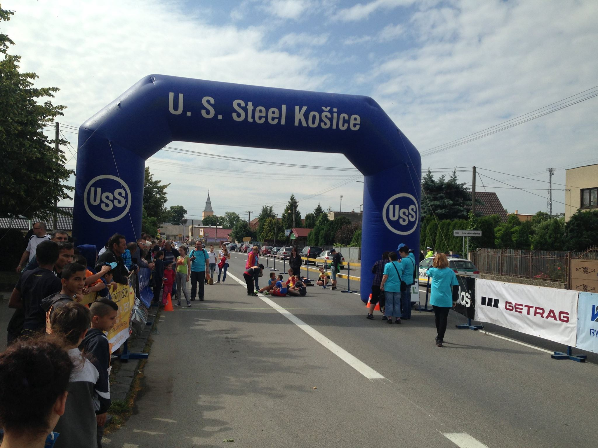

**Obec Seňa, ZŠ Seňa, Maratónsky klub Košice a SOPKA, n.o. Seňa**

**organizujú**

**dňa 17.6.2017 o 8,30 hod. pred kultúrnym domom v Seni**

**pre deti a mládež**

**11. ročník Detského minimaratónu**

|  |  |  |  |  |  |  |  |  |  |  |  |  |  |  |  |  |  |  |  |  |  |  |  |  |  |  |  |  |  |  |  |  |  |  |  |  |  |  |  |  |  |  |  |  |  |  |  |  |  |  |  |  |  |  |  |  |  |  |  |  |  |  |  |  |  |  |  |  |  |  |  |  |  |  |  |  |  |  |  |  |  |  |  |  |  |  |  |  |  |  |  |  |  |  |  |  |
| --- | --- | --- | --- | --- | --- | --- | --- | --- | --- | --- | --- | --- | --- | --- | --- | --- | --- | --- | --- | --- | --- | --- | --- | --- | --- | --- | --- | --- | --- | --- | --- | --- | --- | --- | --- | --- | --- | --- | --- | --- | --- | --- | --- | --- | --- | --- | --- | --- | --- | --- | --- | --- | --- | --- | --- | --- | --- | --- | --- | --- | --- | --- | --- | --- | --- | --- | --- | --- | --- | --- | --- | --- | --- | --- | --- | --- | --- | --- | --- | --- | --- | --- | --- | --- | --- | --- | --- | --- | --- | --- | --- | --- | --- | --- | --- | --- |
| |  |  |  |  |  |  | | --- | --- | --- | --- | --- | --- | | kategórie | | rok narodenia | vek | dĺžka | štart | | D1 | Dievčatá - predškolský vek | do roku 2013 | 4 a menej rokov | 30 m | 8:30 | | Ch1 | Chlapci - predškolský vek | do roku 2013 | 4 a menej rokov | 50 m | 8:35 | | D2 | Dievčatá - predškolský vek | 2012 - 2010 | 5 - 7 rokov | 50 m | 8:40 | | Ch2 | Chlapci - predškolský vek | 2012 - 2010 | 5 - 7 rokov | 100 m | 8:45 | | D3 | Najmladšie žiačky | 2009 - 2008 | 8 - 9 rokov | 100 m | 8:50 | | Ch3 | Najmladší žiaci | 2009 - 2008 | 8 - 9 rokov | 200 m | 8:55 | | D4 | Mladšie žiačky | 2007 - 2006 | 10 - 11 rokov | 200 m | 9:00 | | Ch4 | Mladší žiaci | 2007 - 2006 | 10 - 11 rokov | 400 m | 9:05 | | D5 | Staršie žiačky | 2005 - 2004 | 12 - 13 rokov | 400 m | 9:10 | | Ch5 | Starší žiaci | 2005 - 2004 | 12 - 13 rokov | 600 m | 9:15 | | D6 | Najstaršie žiačky | 2003 - 2002 | 14 - 15 rokov | 600 m | 9:20 | | Ch6 | Najstarší žiaci | 2003 - 2002 | 14 - 15 rokov | 800 m | 9:25 | | D7 | Dorastenky | 2001 - 2000 | 16 - 17 rokov | 800 m | 9:35 | | Ch7 | Dorastenci | 2001 - 2000 | 16 - 17 rokov | 1000 m | 9:45 | | Časy štartu sú iba informatívne o presnom čase rozhodne riaditeľka preteku! | | | | | | |

**Prezentácia: od 7:30 do 8:15 hod.**

**Každý súťažiaci nech si prinesie so sebou preukaz poistenca na overenie dátumu narodenia a vhodnú športovú obuv.**